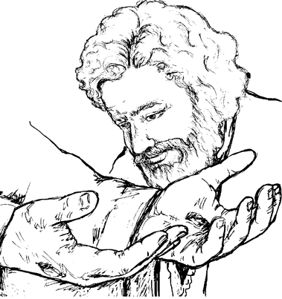

Copyright © Sermons4Kids, Inc.
Todos los derechos reservados
Boletín para niños

¡Créalo o no!

Juan 20:19-31

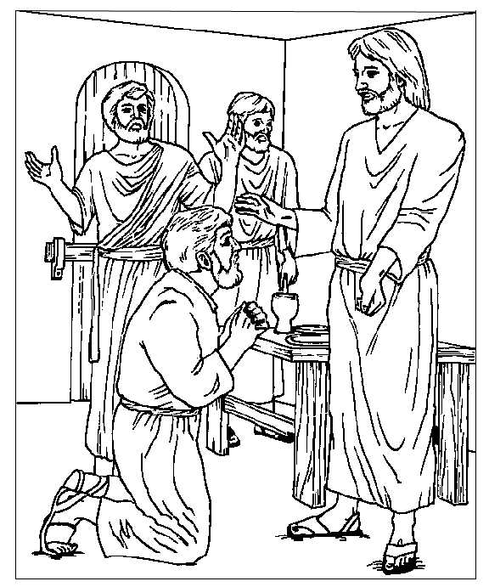
¡Jesús aparece!

From BibleStoryCard Learning System(tm) Coloring Book © 1996 Wesleyan
Publishing House. Used by permission. Additional BibleStoryCard resources
are available by calling 1-800-493-7539 or visiting online
http://www.wesleyan.org/wph/childrensresources/biblestorycards/biblestorycards.htm

